What is Read WOKE

“Read Woke is a movement. It is a feeling. It is a style. It is a form of education. It is a call to action; it is our right as lifelong learners. It means arming yourself with knowledge in order to better protect your rights. Knowledge is power and no one can take it away. It means learning about others so that you can treat people with the respect and dignity that they deserve no matter their religion, race, creed, or color.
I concluded that a Woke Book must:
• Challenge a social norm
• Give voice to the voiceless
• Provide information about a group that has been disenfranchised
• Seek to challenge the status quo
• Have a protagonist from an underrepresented or oppressed group”

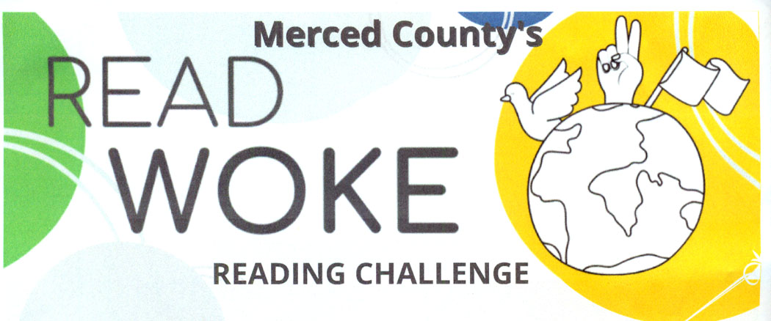
– Cicely Lewis, creator of Read Woke

